**David Tran**

**Hard Disk Simulator**

**CSC 641**

**HW #2**

**Introduction:**

The purpose of this assignment was to create a simulator, that simulates how a hard disk using SSTF (Shortest Seek Time First) disk scheduling algorithm performs under a load. I created a queue that would be populated with a uniformly distributed randomly generated numbers from 0 to 199. I used a queue changing the size from 1 to 20, allowing me to see how average seek time changes when the size of the queue is increased or decreased. The program will simulate 10000 disk accesses with 200 cylinders.

**System:**

CPU: i7-960 3.20GHZ

RAM: 8GB

O/S: Windows 10

Compiler: GCC/Cygwin

Language: C++

**Output:**

**Run with Q=1:**

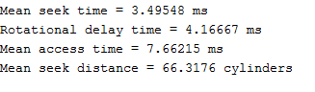

**Run with Q=2:**

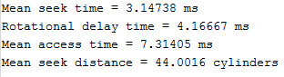

**Run with Q=3:**

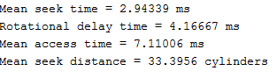

**Run with Q=4:**

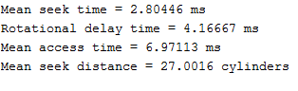

**Run with Q=5:**

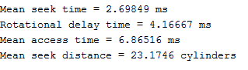

**Run with Q=6:**

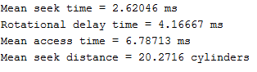

**Run with Q=7:**

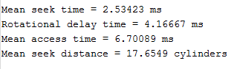

**Run with Q=8:**

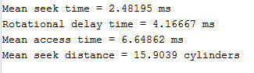

**Run with Q=9:**

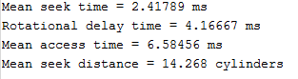

**Run with Q=10:**

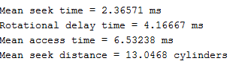

**Run with Q=11:**

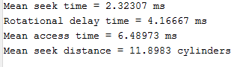

**Run with Q=12:**

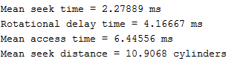

**Run with Q=13:**

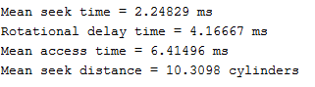

**Run with Q=14:**

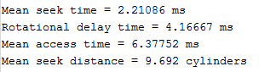

**Run with Q=15:**

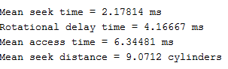

**Run with Q=16:**

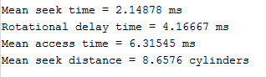

**Run with Q=17:**

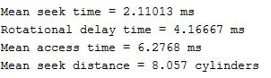

**Run with Q=18:**

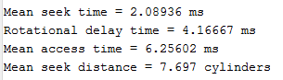

**Run with Q=19:**

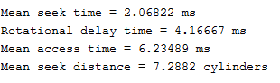

**Run with Q=20:**

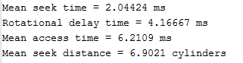

**Experiment:**

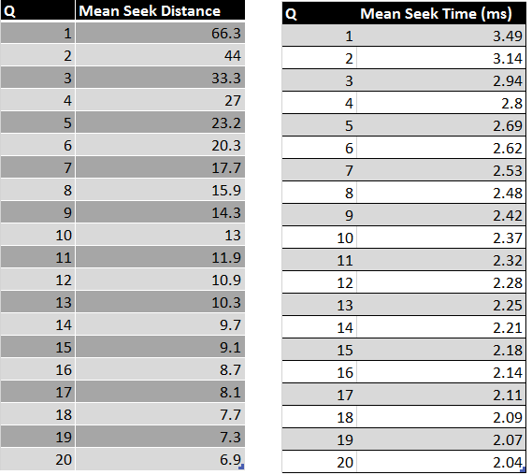**­­­­**

**Above is the tables for both Mean Seek Time and Mean Seek Distance.**

**Graphs:**

We can see in these graphs that by increase the size of the queue the mean seek time and mean seek distance will decrease exponentially but slowing down and flattening out as we reach Q = 20. The graphs show a good representation of a hard disk seek time and distance versus the size of the queue.

**Conclusion:**

This was a very good project to work on to see better see how hard disks handle loads according to how I increase or decrease the size of the queue of cylinders. It allowed me to see how the shortest seek time disk scheduling algorithm works depending on the size of the Q. I noticed as I increase the size of the queue the mean seek time and mean seek distance decreased. Which shows that as the queue increases the faster the simulated hard disk becomes. It makes sense since we are using a Shortest Seek Time First (SSTF) algorithm, as the queue gets bigger we have more cylinders to compare allowing for higher probability of a much closer cylinder.

**Appendix**

